Competition Rules
Your research idea should relate to at least one of the Innovation Community themes:
- Additive Manufacturing
- Drones
- Imaging & Visualization
- Mapping & Geographic Information Systems (GIS)
- Robotics & Artificial Intelligence (AI)
- Virtual and Augmented Reality (VR/AR)

An inter-department application will be looked on favourably as will the innovative nature of the proposal. The total prize fund is £10k to be shared by 2-4 applications, so a maximum application of £5k is expected.

The funding secured from this competition can be used to seed fund a specific piece of research through, for example, the purchase of equipment or equipment time, research software engineer time etc.

The shortlist will be chosen after the deadline date, which will be reviewed by peers from the three faculties. Applicants will be notified whether their application has been successful by Wednesday, 25 March.

A member from the shortlisted applications must be available to present at a showcase event on Thursday 23 April to secure the funding. Unsuccessful applicants and any members of the University are welcome to attend by signing up through Eventbrite nearer the time.

The winning projects will be expected to provide a report outlining the outcomes of their project by 1 October, 2020.

Competition Timeline
To help with planning, please email an expression of interest to innovation@manchester.ac.uk by Monday 2 March, 2020 and please email your application to this address by the deadline.

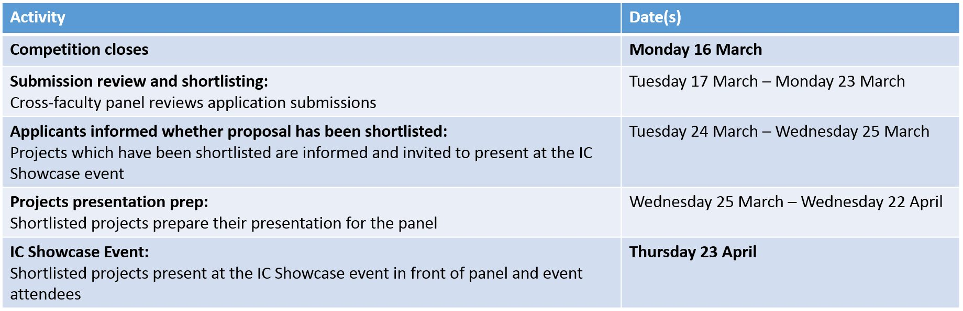
The deadline for applications is 9am, Monday 16th March

Contact the Innovation Community Team (innovation@manchester.ac.uk) if you have any questions about this call or the Innovation Community Project
- Project title:

- List of applicants and UoM Faculty/Department

- Provide a brief description of your proposed research study including appropriate background, theoretical motivation, methods and objectives (<2 pages of A4, including figures).

(2. cont.)

- Outline the funds required in this application and a realistic timeline (please note: funds must be spent by end July 2020).

- How do you envisage these funds in assisting plans for future funding (e.g. targeted funding bodies/calls)

